
Tertiary Infotech Academy Pte Ltd
UEN: 201200696W
LEARNER GUIDE
For
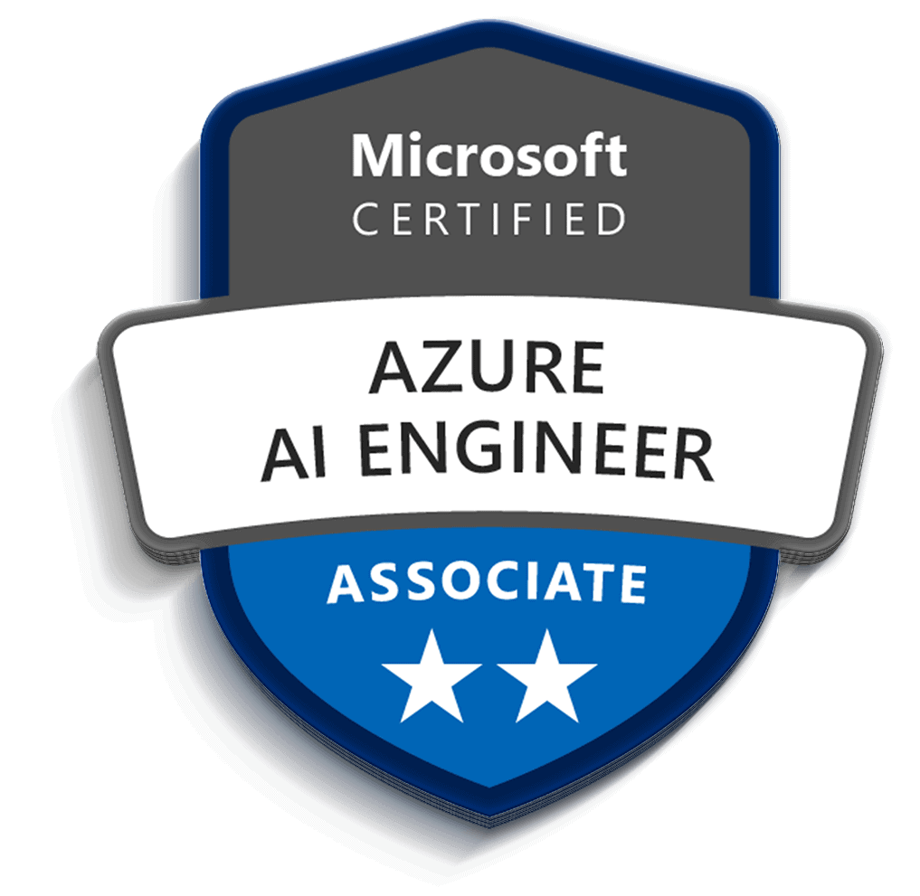
Microsoft Certified Azure AI Engineer Associate AI-102 Training
TGS Ref No: TGS-2023036651
Conducted by
Tertiary Infotech Academy Pte Ltd
UEN: 201200696W
Version 1.0

DOCUMENT VERSION CONTROL RECORD
Version Number | Effective Date of Release | Summary of Included Changes | Author
1.0 | 8 July 2026 | First version aligned to the 10 AI-102 labs, with step-by-step lab guidance and Markdown mirror. | Tertiary Infotech Academy Pte Ltd

TABLE OF CONTENTS
Document Version Control Record 2
Table of Contents 3
Course Overview 4
Before You Start 4
Lab 01 - Plan, Manage, Monitor, and Secure an Azure AI Solution 5
Lab 02 - Responsible AI, Content Safety, Governance 7
Lab 03 - Generative AI, Foundry, Azure OpenAI, Prompt Flow, RAG 9
Lab 04 - Agentic AI, Foundry Agent Service, Multi-Agent Concepts 11
Lab 05 - Computer Vision, Custom Vision, Video Insights 13
Lab 06 - NLP, Language, Speech, Translation 15
Lab 07 - Custom Language Models and Question Answering 17
Lab 08 - Azure AI Search, Knowledge Mining, Vector Search 19
Lab 09 - Document Intelligence and Content Understanding 21
Lab 10 - AI-102 Capstone and Course Review 23
Cleanup Checklist 25

Course Overview
This Learner Guide mirrors the lab sequence for the Microsoft Certified Azure AI Engineer Associate AI-102 Training course. Work through the labs in order and complete every validation check before moving on.
Course Title | Microsoft Certified Azure AI Engineer Associate AI-102 Training
Course Code | TGS-2023036651
TSC Title | Artificial Intelligence Application in Product Development
TSC Code | ICT-TEM-4034-1.1
Duration | 2 days / 16 training hours
Delivery Mode | Instructor-led training with guided Azure AI design and lab activities
Tools | Azure portal, Azure AI Foundry, Azure Cloud Shell, Visual Studio Code, REST client/Postman, Python or C# SDK examples

Before You Start
- Sign in to the Azure subscription or Skillable lab environment provided by the trainer.
- Create lab notes using the recommended files from the Tools Guide.
- Use the same naming convention for resources so cleanup is simple.
- Do not paste real confidential, personal, or customer data into lab prompts or documents.
- At the end of each lab, complete the validation and checkpoint questions.

Lab 01 - Plan, Manage, Monitor, and Secure an Azure AI Solution
Main Topic | Planning and operations
Source Lab | labs/lab-01-plan-manage-secure-azure-ai-solution.md
Reference Diagram | Source PPT slide 25

Objectives
- Select appropriate Azure AI services.
- Plan resource deployment and endpoints.
- Identify authentication, keys, monitoring, and cost controls.
- Prepare an AI solution architecture.

Scenario
A company wants a customer support AI platform with document search, answer generation, sentiment analysis, speech transcription, and image processing. You must plan the Azure AI resources.

Step-by-Step Lab Guide

Step 1: Map Requirements to Services
Requirement | Service
Generate responses | Azure OpenAI in Foundry Models
Search internal documents | Azure AI Search
Analyze sentiment | Azure AI Language
Transcribe calls | Azure AI Speech
Extract text from images | Azure AI Vision
Extract invoice fields | Azure AI Document Intelligence
- Record the required outputs in your lab notes.
- Ask the trainer to verify any uncertain configuration or design decision.

Step 2: Plan Foundry Resources
Document:
Hub or project name
Region
Model deployment
Default endpoint
Connected data source
Responsible AI settings
- Record the required outputs in your lab notes.
- Ask the trainer to verify any uncertain configuration or design decision.

Step 3: Plan Security
Record:
- Role-based access control.
- Managed identities.
- Key protection.
- Private endpoint or network controls.
- Logging and diagnostics.
- Secrets storage.
- Record the required outputs in your lab notes.
- Ask the trainer to verify any uncertain configuration or design decision.

Step 4: Plan Monitoring and Cost
Document:
Token or transaction usage
Latency
Errors
Content safety events
Budget alerts
Diagnostic logs
- Record the required outputs in your lab notes.
- Ask the trainer to verify any uncertain configuration or design decision.

Step 5: Draw Architecture
Use diagrams.net:
Application -> API layer -> Foundry/Azure AI services -> Search index/storage -> Monitoring
- Record the required outputs in your lab notes.
- Ask the trainer to verify any uncertain configuration or design decision.

Validation
You should have a service map, security plan, monitoring plan, and architecture diagram.

Checkpoint Questions
- Why is service selection part of AI engineering?
- Why should keys be protected?
- What should be monitored in an AI service?
- What is the role of responsible AI planning?

Course Focus
AI engineering starts with selecting the right service, securing it, monitoring it, and planning for cost and responsible use.

Lab Alignment Diagram
Lab Input | Design / Build Activity | Validation Output
A company wants a customer support AI platform with document search, answer generation, sentiment analysis, speech transcription, and image processing. You must plan the Azure AI resources. | Map Requirements to Services -> Plan Foundry Resources -> Plan Security -> Plan Monitoring and Cost -> Draw Architecture | You should have a service map, security plan, monitoring plan, and architecture diagram.

Imported Reference Diagram
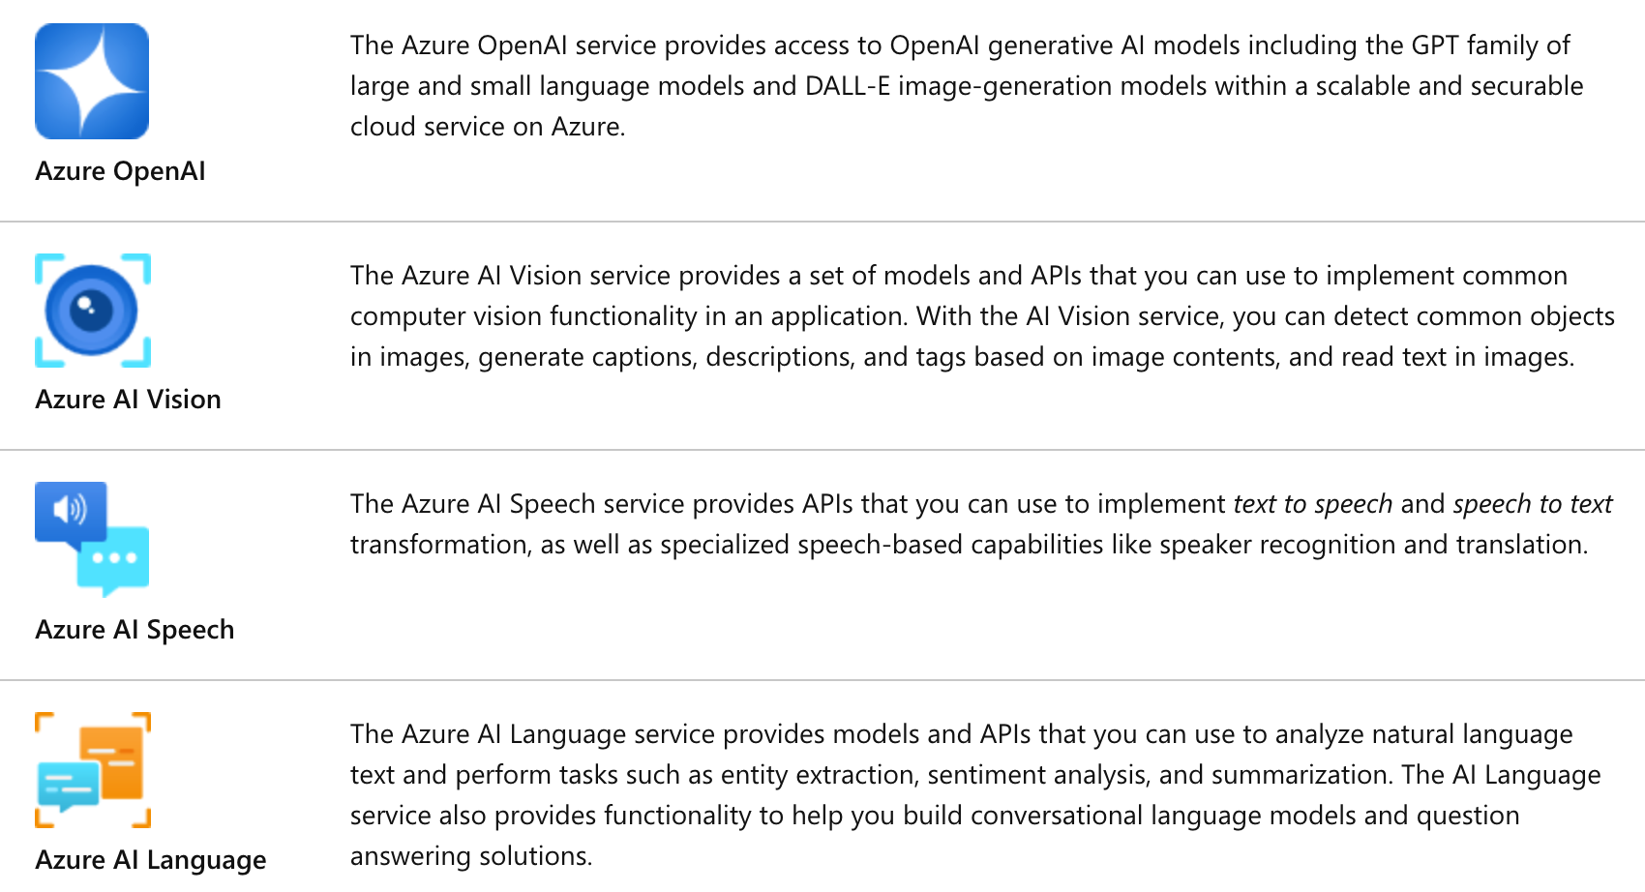
Reference image imported from source PPT slide 25.

Lab 02 - Responsible AI, Content Safety, Governance
Main Topic | Responsible AI
Source Lab | labs/lab-02-responsible-ai-content-safety-governance.md
Reference Diagram | No imported image asset found for this lab topic

Objectives
- Apply responsible AI principles.
- Configure content safety concepts.
- Explain content filters, blocklists, prompt shields, and harm detection.
- Design a responsible AI governance framework.

Scenario
The support AI assistant may receive abusive user input, produce inaccurate answers, or expose sensitive data. You must design responsible AI controls.

Step-by-Step Lab Guide

Step 1: Review Responsible AI Principles
Write one control for:
Fairness
Reliability and safety
Privacy and security
Inclusiveness
Transparency
Accountability
- Record the required outputs in your lab notes.
- Ask the trainer to verify any uncertain configuration or design decision.

Step 2: Define Content Safety Controls
Document:
- Harm categories.
- Severity levels.
- Content filters.
- Blocklists.
- Prompt shields.
- Groundedness checks.
- Human escalation rules.
- Record the required outputs in your lab notes.
- Ask the trainer to verify any uncertain configuration or design decision.

Step 3: Create a Safety Policy
Write:
Allowed use:
Disallowed use:
Blocked content:
Human review trigger:
Audit log requirement:
Escalation owner:
Review frequency:
- Record the required outputs in your lab notes.
- Ask the trainer to verify any uncertain configuration or design decision.

Step 4: Test Governance Scenarios
Decide what should happen when:
- User asks for harmful instructions.
- Model produces low-confidence answer.
- Prompt contains personal data.
- Retrieved document is outdated.
- User asks for legal advice.
- Record the required outputs in your lab notes.
- Ask the trainer to verify any uncertain configuration or design decision.

Step 5: Create an Incident Plan
Define how to report, investigate, remediate, and prevent repeat AI safety incidents.
- Record the required outputs in your lab notes.
- Ask the trainer to verify any uncertain configuration or design decision.

Validation
You should have responsible AI controls, safety policy, scenario decisions, and incident plan.

Checkpoint Questions
- What are content filters?
- What is a prompt shield?
- Why is human escalation important?
- Who is accountable for AI output?

Course Focus
Responsible AI is implemented through policy, configuration, monitoring, human review, and governance.

Lab Alignment Diagram
Lab Input | Design / Build Activity | Validation Output
The support AI assistant may receive abusive user input, produce inaccurate answers, or expose sensitive data. You must design responsible AI controls. | Review Responsible AI Principles -> Define Content Safety Controls -> Create a Safety Policy -> Test Governance Scenarios -> Create an Incident Plan | You should have responsible AI controls, safety policy, scenario decisions, and incident plan.

Lab 03 - Generative AI, Foundry, Azure OpenAI, Prompt Flow, RAG
Main Topic | Generative AI
Source Lab | labs/lab-03-generative-ai-foundry-openai-prompt-flow-rag.md
Reference Diagram | Source PPT slide 309

Objectives
- Plan a generative AI solution with Microsoft Foundry.
- Select and deploy a model conceptually.
- Design prompt templates and prompt flow.
- Implement a RAG pattern conceptually.
- Evaluate model and flow outputs.

Scenario
The company wants a grounded assistant that answers questions from internal support articles and generates draft replies.

Step-by-Step Lab Guide

Step 1: Select a Model
Record:
Model name
Use case fit
Context window
Latency
Cost
Safety settings
Deployment option
- Record the required outputs in your lab notes.
- Ask the trainer to verify any uncertain configuration or design decision.

Step 2: Design Prompt Templates
Create templates for:
- Direct answer.
- Answer with sources.
- Escalation when context is missing.
- Record the required outputs in your lab notes.
- Ask the trainer to verify any uncertain configuration or design decision.

Step 3: Plan Prompt Flow
Draw:
User question -> classify intent -> retrieve context -> prompt template -> model -> safety check -> response
- Record the required outputs in your lab notes.
- Ask the trainer to verify any uncertain configuration or design decision.

Step 4: Design RAG
Document:
- Source documents.
- Cleaning.
- Chunking.
- Embeddings.
- Vector store.
- Retrieval filters.
- Citation format.
- Evaluation method.
- Record the required outputs in your lab notes.
- Ask the trainer to verify any uncertain configuration or design decision.

Step 5: Evaluate Outputs
Score:
Criterion | Score 1-5
Correctness
Grounding
Helpfulness
Safety
Conciseness
- Record the required outputs in your lab notes.
- Ask the trainer to verify any uncertain configuration or design decision.

Validation
You should have model selection notes, prompt templates, prompt flow diagram, RAG design, and evaluation table.

Checkpoint Questions
- What is RAG?
- Why are prompt templates useful?
- What does tracing help debug?
- How can feedback improve a generative AI solution?

Course Focus
Generative AI solutions need grounded data, evaluation, safety settings, monitoring, and feedback loops.

Lab Alignment Diagram
Lab Input | Design / Build Activity | Validation Output
The company wants a grounded assistant that answers questions from internal support articles and generates draft replies. | Select a Model -> Design Prompt Templates -> Plan Prompt Flow -> Design RAG -> Evaluate Outputs | You should have model selection notes, prompt templates, prompt flow diagram, RAG design, and evaluation table.

Imported Reference Diagram
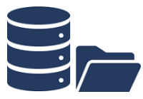
Reference image imported from source PPT slide 309.

Lab 04 - Agentic AI, Foundry Agent Service, Multi-Agent Concepts
Main Topic | Agents
Source Lab | labs/lab-04-agentic-ai-foundry-agent-service.md
Reference Diagram | No imported image asset found for this lab topic

Objectives
- Explain agent roles and use cases.
- Plan Foundry Agent Service resources.
- Design custom agent tools and workflows.
- Review multi-agent orchestration concepts.

Scenario
The support AI assistant needs to look up order status, search support documents, draft a reply, and escalate complex cases to a human agent.

Step-by-Step Lab Guide

Step 1: Define Agent Use Case
Write:
Agent goal:
User types:
Allowed tools:
Disallowed actions:
Human escalation trigger:
Success metric:
- Record the required outputs in your lab notes.
- Ask the trainer to verify any uncertain configuration or design decision.

Step 2: Plan Agent Resources
Document:
- Foundry project.
- Model deployment.
- Search tool.
- Function or API tools.
- Authentication.
- Logging and trace settings.
- Record the required outputs in your lab notes.
- Ask the trainer to verify any uncertain configuration or design decision.

Step 3: Design Tool Calls
Create a table:
Tool | Purpose | Input | Output
Search knowledge base | Retrieve support articles | Query | Relevant passages
Order lookup | Get order status | Order ID | Status summary
- Record the required outputs in your lab notes.
- Ask the trainer to verify any uncertain configuration or design decision.

Step 4: Design Orchestration
Draw:
User request -> agent plan -> tool call -> observation -> model reasoning -> response -> feedback
- Record the required outputs in your lab notes.
- Ask the trainer to verify any uncertain configuration or design decision.

Step 5: Multi-Agent Review
Explain when separate agents might be useful for retrieval, billing, technical support, and escalation review.
- Record the required outputs in your lab notes.
- Ask the trainer to verify any uncertain configuration or design decision.

Validation
You should have agent use case, resource plan, tool table, orchestration diagram, and multi-agent notes.

Checkpoint Questions
- What is an AI agent?
- Why do agents need tool permissions?
- What is orchestration?
- Why should autonomous actions be constrained?

Course Focus
Agentic solutions combine models, tools, workflows, monitoring, safety controls, and human escalation.

Lab Alignment Diagram
Lab Input | Design / Build Activity | Validation Output
The support AI assistant needs to look up order status, search support documents, draft a reply, and escalate complex cases to a human agent. | Define Agent Use Case -> Plan Agent Resources -> Design Tool Calls -> Design Orchestration -> Multi-Agent Review | You should have agent use case, resource plan, tool table, orchestration diagram, and multi-agent notes.

Lab 05 - Computer Vision, Custom Vision, Video Insights
Main Topic | Vision
Source Lab | labs/lab-05-computer-vision-custom-vision-video.md
Reference Diagram | Source PPT slide 73

Objectives
- Analyze images with Azure AI Vision concepts.
- Select visual features for image processing requirements.
- Compare image classification and object detection.
- Plan custom vision training.
- Explain video insight scenarios.

Scenario
The company wants to inspect product photos, detect damaged items, read text from images, and extract insights from product demo videos.

Step-by-Step Lab Guide

Step 1: Map Vision Requirements
Requirement | Vision Capability
Generate image tags | Image analysis
Detect product locations | Object detection
Read text from photos | OCR
Classify product condition | Image classification
Extract video topics | Video insights
- Record the required outputs in your lab notes.
- Ask the trainer to verify any uncertain configuration or design decision.

Step 2: Plan an Image Request
Document:
Image source
Visual features
Language
Expected response fields
Error handling
Privacy considerations
- Record the required outputs in your lab notes.
- Ask the trainer to verify any uncertain configuration or design decision.

Step 3: Custom Vision Plan
Choose:
Need | Model Type
One label for each image | Image classification
Locate multiple objects | Object detection
Document image labels, training images, evaluation metrics, publishing, and consumption.
- Record the required outputs in your lab notes.
- Ask the trainer to verify any uncertain configuration or design decision.

Step 4: Video Insights Plan
Explain how Video Indexer can extract:
- Transcript.
- Keywords.
- Faces or speakers where appropriate.
- Topics.
- Scenes.
- Record the required outputs in your lab notes.
- Ask the trainer to verify any uncertain configuration or design decision.

Step 5: Responsible AI Review
Document consent, retention, face analysis sensitivity, and human review needs.
- Record the required outputs in your lab notes.
- Ask the trainer to verify any uncertain configuration or design decision.

Validation
You should have vision mapping, request plan, custom vision plan, video insight notes, and responsible AI review.

Checkpoint Questions
- What is OCR?
- How is object detection different from classification?
- What does a custom vision model require?
- Why is video analysis sensitive?

Course Focus
Vision solutions require selecting visual features, model type, evaluation approach, and responsible data handling.

Lab Alignment Diagram
Lab Input | Design / Build Activity | Validation Output
The company wants to inspect product photos, detect damaged items, read text from images, and extract insights from product demo videos. | Map Vision Requirements -> Plan an Image Request -> Custom Vision Plan -> Video Insights Plan -> Responsible AI Review | You should have vision mapping, request plan, custom vision plan, video insight notes, and responsible AI review.

Imported Reference Diagram
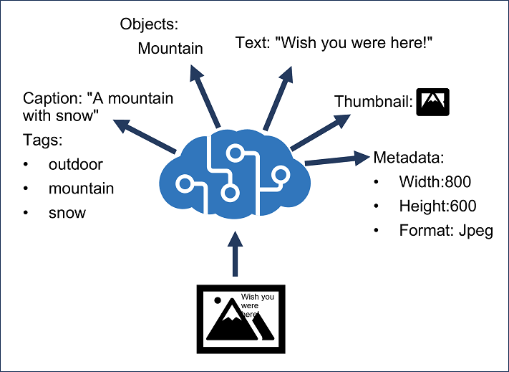
Reference image imported from source PPT slide 73.

Lab 06 - NLP, Language, Speech, Translation
Main Topic | Language and speech
Source Lab | labs/lab-06-nlp-language-speech-translation.md
Reference Diagram | Source PPT slide 61

Objectives
- Analyze and translate text.
- Extract key phrases, entities, PII, language, and sentiment.
- Process speech with speech-to-text and text-to-speech.
- Plan translation and SSML use.

Scenario
The support platform must analyze customer messages, detect PII, translate text, transcribe calls, and generate spoken responses.

Step-by-Step Lab Guide

Step 1: Map Language Tasks
Scenario | Capability
Identify customer sentiment | Sentiment analysis
Extract product names | Entity recognition
Identify important topics | Key phrase extraction
Detect personal data | PII detection
Detect message language | Language detection
Translate message | Translator
- Record the required outputs in your lab notes.
- Ask the trainer to verify any uncertain configuration or design decision.

Step 2: Design Text Analysis Pipeline
Input text -> language detection -> PII detection -> sentiment -> entities -> key phrases -> route case
- Record the required outputs in your lab notes.
- Ask the trainer to verify any uncertain configuration or design decision.

Step 3: Design Speech Pipeline
Audio input -> speech to text -> intent or keyword recognition -> response -> text to speech
- Record the required outputs in your lab notes.
- Ask the trainer to verify any uncertain configuration or design decision.

Step 4: SSML Review
Explain how SSML can control voice, pitch, rate, pauses, and pronunciation.
- Record the required outputs in your lab notes.
- Ask the trainer to verify any uncertain configuration or design decision.

Step 5: Translation Review
Document:
- Text translation.
- Document translation.
- Speech-to-text translation.
- Speech-to-speech translation.
- Human review for critical messages.
- Record the required outputs in your lab notes.
- Ask the trainer to verify any uncertain configuration or design decision.

Validation
You should have language task mapping, text pipeline, speech pipeline, SSML notes, and translation notes.

Checkpoint Questions
- What is entity recognition?
- Why detect PII before storing text?
- What is SSML?
- When should translation outputs be reviewed?

Course Focus
Language and speech solutions combine analysis, privacy controls, translation, and application integration.

Lab Alignment Diagram
Lab Input | Design / Build Activity | Validation Output
The support platform must analyze customer messages, detect PII, translate text, transcribe calls, and generate spoken responses. | Map Language Tasks -> Design Text Analysis Pipeline -> Design Speech Pipeline -> SSML Review -> Translation Review | You should have language task mapping, text pipeline, speech pipeline, SSML notes, and translation notes.

Imported Reference Diagram
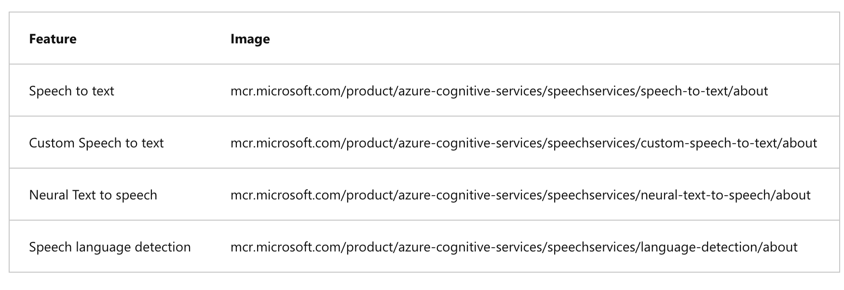
Reference image imported from source PPT slide 61.

Lab 07 - Custom Language Models and Question Answering
Main Topic | Custom language
Source Lab | labs/lab-07-custom-language-question-answering.md
Reference Diagram | Source PPT slide 149

Objectives
- Design custom language understanding.
- Define intents, entities, and utterances.
- Plan custom question answering.
- Create a multilingual question answering strategy.

Scenario
The support assistant must recognize customer intents and answer frequently asked questions from approved sources.

Step-by-Step Lab Guide

Step 1: Define Intents and Entities
Create a table:
Intent | Example Utterance | Entities
CheckOrderStatus | Where is order 12345? | order number
RequestRefund | I want a refund for my laptop | product
- Record the required outputs in your lab notes.
- Ask the trainer to verify any uncertain configuration or design decision.

Step 2: Plan Training Data
Document:
- Number of example utterances.
- Balanced examples across intents.
- Entity labeling rules.
- Test set.
- Ambiguous utterances.
- Record the required outputs in your lab notes.
- Ask the trainer to verify any uncertain configuration or design decision.

Step 3: Plan Custom Question Answering
Record:
Knowledge sources
Q&A pairs
Alternate phrasing
Chit-chat
Multi-turn prompts
Publishing target
Fallback answer
- Record the required outputs in your lab notes.
- Ask the trainer to verify any uncertain configuration or design decision.

Step 4: Multilingual Strategy
Explain whether to translate sources, create separate projects, or translate user input before answering.
- Record the required outputs in your lab notes.
- Ask the trainer to verify any uncertain configuration or design decision.

Step 5: Backup and Recovery
Document export, versioning, backup, and recovery of language projects.
- Record the required outputs in your lab notes.
- Ask the trainer to verify any uncertain configuration or design decision.

Validation
You should have intent/entity table, training plan, question answering plan, multilingual strategy, and backup notes.

Checkpoint Questions
- What is an intent?
- What is an entity?
- Why add alternate phrasing?
- Why should language projects be backed up?

Course Focus
Custom language solutions need well-designed examples, evaluation, publishing, and lifecycle management.

Lab Alignment Diagram
Lab Input | Design / Build Activity | Validation Output
The support assistant must recognize customer intents and answer frequently asked questions from approved sources. | Define Intents and Entities -> Plan Training Data -> Plan Custom Question Answering -> Multilingual Strategy -> Backup and Recovery | You should have intent/entity table, training plan, question answering plan, multilingual strategy, and backup notes.

Imported Reference Diagram
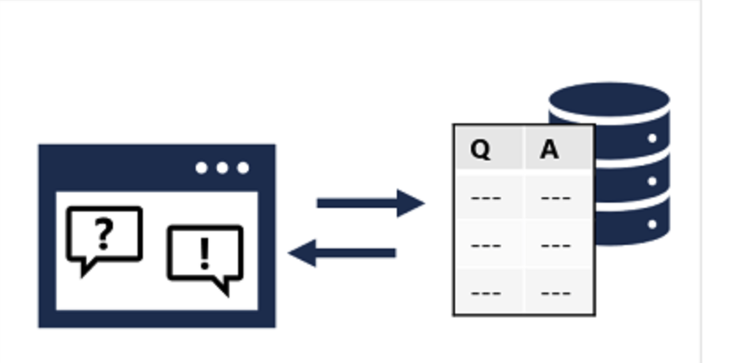
Reference image imported from source PPT slide 149.

Lab 08 - Azure AI Search, Knowledge Mining, Vector Search
Main Topic | Search and mining
Source Lab | labs/lab-08-ai-search-knowledge-mining-vector-search.md
Reference Diagram | Source PPT slide 380

Objectives
- Design an Azure AI Search solution.
- Define indexes, data sources, indexers, and skillsets.
- Explain semantic and vector search.
- Plan knowledge store projections.

Scenario
The company wants searchable support documents, enriched with extracted text, entities, key phrases, and vector embeddings for RAG.

Step-by-Step Lab Guide

Step 1: Design an Index
Define fields:
id
title
content
category
source_url
last_updated
security_label
embedding
- Record the required outputs in your lab notes.
- Ask the trainer to verify any uncertain configuration or design decision.

Step 2: Plan Data Sources and Indexers
Document:
- Source storage.
- Supported document formats.
- Indexer schedule.
- Change detection.
- Error handling.
- Record the required outputs in your lab notes.
- Ask the trainer to verify any uncertain configuration or design decision.

Step 3: Define a Skillset
Include:
- OCR.
- Language detection.
- Entity extraction.
- Key phrase extraction.
- Custom skill.
- Embedding generation.
- Record the required outputs in your lab notes.
- Ask the trainer to verify any uncertain configuration or design decision.

Step 4: Query Design
Write examples for:
Keyword search
Filter by category
Sort by last updated
Wildcard query
Semantic ranking
Vector search
Hybrid search
- Record the required outputs in your lab notes.
- Ask the trainer to verify any uncertain configuration or design decision.

Step 5: Knowledge Store Projections
Explain file, object, and table projections and when enriched output should be stored.
- Record the required outputs in your lab notes.
- Ask the trainer to verify any uncertain configuration or design decision.

Validation
You should have index design, data source/indexer plan, skillset plan, query examples, and knowledge store notes.

Checkpoint Questions
- What is an indexer?
- What is a skillset?
- What is vector search?
- Why use semantic ranking?

Course Focus
Knowledge mining combines source data, enrichment, indexing, querying, and optional vector retrieval for AI applications.

Lab Alignment Diagram
Lab Input | Design / Build Activity | Validation Output
The company wants searchable support documents, enriched with extracted text, entities, key phrases, and vector embeddings for RAG. | Design an Index -> Plan Data Sources and Indexers -> Define a Skillset -> Query Design -> Knowledge Store Projections | You should have index design, data source/indexer plan, skillset plan, query examples, and knowledge store notes.

Imported Reference Diagram
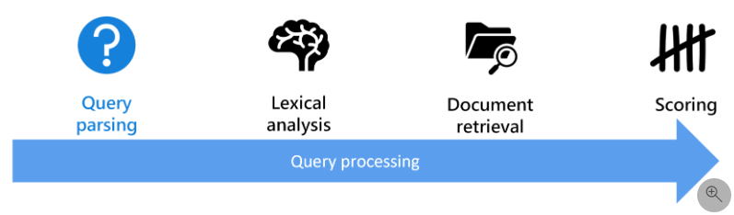
Reference image imported from source PPT slide 380.

Lab 09 - Document Intelligence and Content Understanding
Main Topic | Document AI
Source Lab | labs/lab-09-document-intelligence-content-understanding.md
Reference Diagram | Source PPT slide 532

Objectives
- Use prebuilt document extraction concepts.
- Plan custom Document Intelligence models.
- Explain composed models.
- Design Content Understanding extraction workflows.

Scenario
The company processes invoices, contracts, support screenshots, audio notes, and product videos. It wants to extract structured information from multiple content types.

Step-by-Step Lab Guide

Step 1: Map Document Scenarios
Scenario | Capability
Extract invoice fields | Prebuilt invoice model
Extract custom form fields | Custom document model
Route different form types | Composed model
Extract table data | Layout and table extraction
Extract text from images | OCR pipeline
- Record the required outputs in your lab notes.
- Ask the trainer to verify any uncertain configuration or design decision.

Step 2: Custom Document Model Plan
Document:
Document types
Sample count
Fields to extract
Labels
Training split
Evaluation metric
Publish plan
- Record the required outputs in your lab notes.
- Ask the trainer to verify any uncertain configuration or design decision.

Step 3: Content Understanding Plan
Explain extraction from:
- Documents.
- Images.
- Video.
- Audio.
Include summarization, classification, attributes, entities, tables, and images.
- Record the required outputs in your lab notes.
- Ask the trainer to verify any uncertain configuration or design decision.

Step 4: Human Review Rules
Define confidence thresholds and when extracted data requires review.
- Record the required outputs in your lab notes.
- Ask the trainer to verify any uncertain configuration or design decision.

Step 5: Integration Flow
Draw:
Upload content -> extract text/entities/tables -> validate -> store structured data -> search/report
- Record the required outputs in your lab notes.
- Ask the trainer to verify any uncertain configuration or design decision.

Validation
You should have scenario mapping, custom model plan, content understanding plan, review rules, and integration flow.

Checkpoint Questions
- When should you use a prebuilt model?
- What is a composed model?
- Why are confidence scores useful?
- What content types can Content Understanding process?

Course Focus
Information extraction solutions need model selection, training data, confidence handling, and integration design.

Lab Alignment Diagram
Lab Input | Design / Build Activity | Validation Output
The company processes invoices, contracts, support screenshots, audio notes, and product videos. It wants to extract structured information from multiple content types. | Map Document Scenarios -> Custom Document Model Plan -> Content Understanding Plan -> Human Review Rules -> Integration Flow | You should have scenario mapping, custom model plan, content understanding plan, review rules, and integration flow.

Imported Reference Diagram
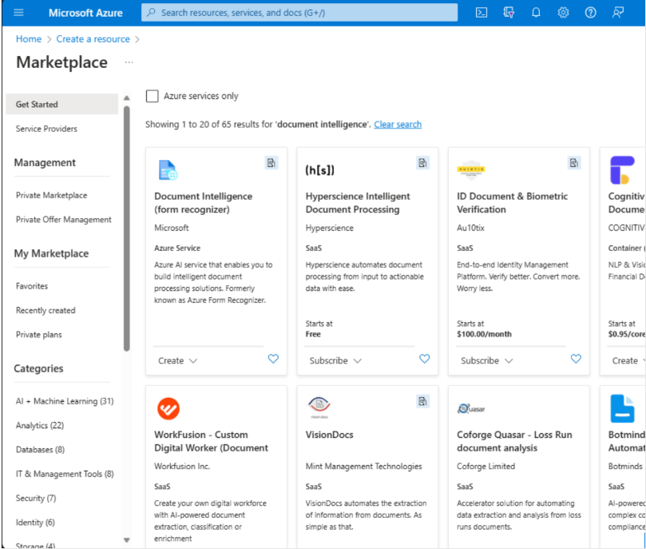
Reference image imported from source PPT slide 532.

Lab 10 - AI-102 Capstone and Course Review
Main Topic | Integrated review
Source Lab | labs/lab-10-ai102-capstone-course-review.md
Reference Diagram | Source PPT slide 716

Objectives
- Design an end-to-end Azure AI solution.
- Map requirements to Microsoft Foundry and Azure AI services.
- Include security, monitoring, responsible AI, and cost controls.
- Build a personal review plan.

Scenario
You must design a production-ready customer support AI platform that supports grounded chat, document search, sentiment analysis, speech transcription, image OCR, document extraction, and human escalation.

Step-by-Step Lab Guide

Step 1: Build a Service Map
Requirement | Service
Grounded assistant | Foundry, Azure OpenAI, prompt flow, RAG
Agent workflow | Foundry Agent Service
Document search | Azure AI Search
Sentiment and PII | Azure AI Language
Speech transcription | Azure AI Speech
Image OCR | Azure AI Vision
Invoice extraction | Document Intelligence
Multi-content extraction | Content Understanding
Safety controls | Content Safety and responsible AI governance
- Record the required outputs in your lab notes.
- Ask the trainer to verify any uncertain configuration or design decision.

Step 2: Draw the Architecture
Include:
User application
API layer
Foundry project
Model deployment
AI Search index
Storage
Language/Speech/Vision/Document services
Monitoring
Human review queue
- Record the required outputs in your lab notes.
- Ask the trainer to verify any uncertain configuration or design decision.

Step 3: Add Governance Controls
Document:
- RBAC.
- Managed identity.
- Key protection.
- Prompt filters.
- Content safety.
- Logging and monitoring.
- Budget alerts.
- Data retention.
- Human escalation.
- Record the required outputs in your lab notes.
- Ask the trainer to verify any uncertain configuration or design decision.

Step 4: Rate Skill Confidence
Skill Area | Confidence 1-5 | Study Action
Plan and manage Azure AI solution
Implement generative AI solutions
Implement agentic solution
Implement computer vision solutions
Implement NLP solutions
Implement knowledge mining and information extraction
- Record the required outputs in your lab notes.
- Ask the trainer to verify any uncertain configuration or design decision.

Step 5: Clean Up Resources
If you created resources:
az group delete --name rg-ai102-lab --yes --no-wait
Confirm with your instructor before deleting shared resources.
- Record the required outputs in your lab notes.
- Ask the trainer to verify any uncertain configuration or design decision.

Step 6: Create a 7-Day Review Plan
- Day 1: Planning, security, monitoring, responsible AI.
- Day 2: Generative AI, prompt flow, RAG.
- Day 3: Agents and orchestration.
- Day 4: Vision and video.
- Day 5: NLP, speech, translation, question answering.
- Day 6: AI Search, Document Intelligence, Content Understanding.
- Day 7: Capstone review and mistakes log.
- Record the required outputs in your lab notes.
- Ask the trainer to verify any uncertain configuration or design decision.

Validation
You should have a service map, architecture diagram, governance checklist, confidence matrix, cleanup plan, and review plan.

Checkpoint Questions
- Which service should power grounded document search?
- When should a human review AI output?
- What is the difference between RAG and fine-tuning?
- Which AI workload do you need to review most?

Course Focus
Azure AI engineering is about integrating the right AI services into secure, monitored, responsible, production-ready solutions.

Lab Alignment Diagram
Lab Input | Design / Build Activity | Validation Output
You must design a production-ready customer support AI platform that supports grounded chat, document search, sentiment analysis, speech transcription, image OCR, document extraction, and human escalation. | Build a Service Map -> Draw the Architecture -> Add Governance Controls -> Rate Skill Confidence -> Clean Up Resources -> Create a 7-Day Review Plan | You should have a service map, architecture diagram, governance checklist, confidence matrix, cleanup plan, and review plan.

Imported Reference Diagram
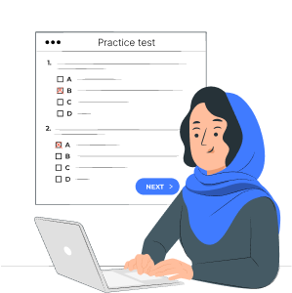
Reference image imported from source PPT slide 716.

Cleanup Checklist
- Delete training resource groups only when instructed by the trainer.
- Remove Foundry projects, model deployments, search indexes, storage accounts, and document processing resources created only for training.
- Confirm that no lab keys, endpoint values, or copied sample data remain in shared notes.

